Pre-Calc/ Trig III Chapter 4 **REVIEW** Name

Date Block

Find all six trig functions of an angle whose terminal side contains the given point.

1. (4, -3) sin θ = csc θ =

cos θ = sec θ =

tan θ = cot θ =

2. () sin θ = csc θ =

cos θ = sec θ =

tan θ = cot θ =

3. (-6, ) sin θ = csc θ =

cos θ = sec θ =

tan θ = cot θ =

4. (  ) sin θ = csc θ =

cos θ = sec θ =

tan θ = cot θ =

Find the missing five trig functions of θ.

5. cos θ =  in quadrant IV sin θ = csc θ =

sec θ =

tan θ = cot θ =

6. cot θ =  in quadrant III sin θ = csc θ =

cos θ = sec θ =

tan θ =

7. csc θ =  in quadrant I sin θ =

cos θ = sec θ =

tan θ = cot θ =

For each of the following angles, find the measure of the angle in standard position and the reference angle.

8.  standard position

reference angle

9. -570° standard position

reference angle

Solve each of the following triangles for the missing information in △PQR.

10. <R = 45°, p = 13, q = 19 <Q =

<P =

r =

11. <Q = 129.7°, <P = 23.8°, p = 112 <R =

r =

q =

12. <R = 29.8°, r = 28.6, q = 35.8 <Q =

<P =

p =

13. q = 12, p = 13, r = 20 <Q =

<R =

<P =

14. <P = 103.4, q = 81.3, p = 98.4 <Q =

<R =

r =

15. Your angle of elevation to the top of a 500-foot tower is 68°. How far are you from the base of the tower.

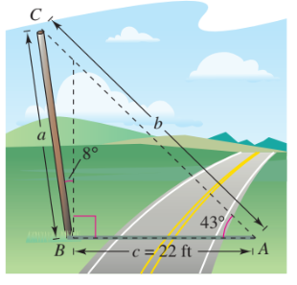16. A pole tilts toward the sun at an 8° angle from the vertical, and it cast a 22 foot shadow. The angle of elevation from the tip of the shadow to the top of the pole is 43°. How tall is the pole?

17. Smile!!!!

Find the exact values of the following trig functions.

18. sin 330° 19. cot  18.

19.

20. sec -240° 21. cos 45° 20.

21.

22. csc 3 23. cot -90° 22.

23.

24. tan  25. sin  24.

25.

26. cot –225 27. csc  26.

27.

28. sec 540° 29. tan  28.

29.